**The Excel Sheet with Scripts and Formulas**

**Overview:**

**What is a snaglist?**

The Snaglist is a kind of a typical Technical Documentation that consists of all the errors with detailed comments and recommendations which is personalized and individually checked for each parameter at the client side by a performance engineer. For the Snaglist Each and every parameter in the system are checked for operation in a designed range and an appropriate value to guarantee the savings to the user. **E.g.:** In the Case of an HVAC system each parameter like the temperature setpoints, Chiller Modulation Valve the Motor VFD control Speeds etc. are checked for desired Range of operations and are then reported OK or Not in the Snaglist. Apart from the Snags, the performance engineer also suggests the possible changes that must be done on the system in order to do the savings and suggest certain points that must be fine-tuned in the system in order to save energy.

**What is a AUTO-SNAGLIST?**

The Auto snag is a tool designed using excel formulas which check for faults in an BSM system automatically once configured to work for a site. The Auto snag tool can analyse for all the faults in the BMS system based on certain conditions which are set by the engineers to make sure all the components are working properly on the client side and suggest him the faults that need to be fixed in order the make sure the system is working properly and energy is not being wasted unnecessarily by any component in the system.

The Auto snag can help reduce the remote health check time drastically (from ~2 hours to just 5-10 minutes at max for any site once configured correctly for any site) and hence save the time and man hours needed to perform a REMOTE HEALTH CHECK for a site. Also the level of detail that the auto snag tool provides is much higher that the snaglist that is generated manually for a site.

**The AHU Snaglist**

**Sheet Parameters:**

(The values in Yellow are provided by the user from the site during REMOTE HEALTH CHECK

The values in cyan are computed automatically based upon the entry of the Yellow marked parameters)

* **Main Page Title:** The Main page title depicts the page which is being referred with regard to the set which is being evaluated on the site
* **Meter:** This Depicts the meter or the datapoint which is being referred to with respect to the analysis.
* **Auto/Manual Status:** The Auto manual status depicts the mode of operation which is set by the BMS operator on the AHU panel.
* **Action:** Based upon the auto/manual status the Action value is computed automatically which tell whether we are running the scripts further or not as If the Auto manual status is set to manual there is no need to check the parameters.
* **Status:** The Status depicts the run status of the AHU that whether the AHU is running or not actually (Feedback Datapoint).
* **Command:** The command is the instruction passed to the AHU which indicates whether the Ahu has to run or not at any given point of time. The command is set by the controller in case of AUTO and manually by the BMS operator in case of Manual operation mode.
* **Status vs Command Test:** The status vs command check is done to check if the AHU is performing as per the given commands or not. This Parameter is Automatically calculated by the status and the command values.
* **RAT:** The Return air temperature is the temperature of the air at the end of the ahu where the AHU returns the processed air.
* **RAT Value Status:** The RAT Value Status is a dynamic status indicator which indicates errors in the return air temperatures of the AHU either due to machine failure or user errors based on the AHU run status and the actual return air temperature from the AHU via a temperature sensor.
* **Temperature Setpoint:** The Temperature setpoint which the user wants a particular AHU to return in a section at the Return point.
* **CHW Valve Modulation:** The CHW valve modulation indicates the amount of opening of the valve which allows the inlet of water from the source into the chiller.
* **Delta:** Delta is simply the temperature difference between the Return air temperature and the temperature setpoint. By using delta we get an idea of how much more colling is required etc. A positive delta means the we still need to provide more cooling, zero means that the Return air temperature has met the temperature setpoint and a negative delta means that we have dropped the return air temperature beyond the setpoint i.e. the room is over cooled now where the corresponding AHU is installed.
* **Recommended Valve opening:** It is the recommended amount of valve opening that must be provided at the inlet point for water at the chiller which is computed based on the delta that we need to reach the temperature setpoint.
* **Valve status Comment:** The Valve status comment is the comparison output of the actual CHW valve opening and the recommended valve opening and based upon that we raise the OK status or the fault status.
* **Comment:** Based on the valve status comment we analyse wether the valve is open more than the requirement or less than the necessary requirement and generate a comment to indicate the same.

**Conditions to detect the faults:**

* **Action:** For predicting the action we make use of the auto/manual status in order to tell whether we are going to run the further rule checks or not on the system as a system in manual cannot be commented upon.

Check-We will be running the scripts

XX- we will not be running the scripts

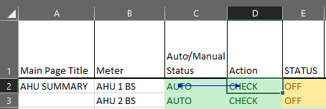

**Precedent- Dependent relation**

**Formula: =IF(EXACT(C2,"AUTO"),"CHECK","XX")**

* **Status vs Command Check:** When the system is running in the automatic mode we need to make sure that the command that we are giving to the AHU via the controller is matching the actual running status of the AHU so we run the following check on it. In case the AHU is operated in the manual mode we need not care about this and give the status as OK.

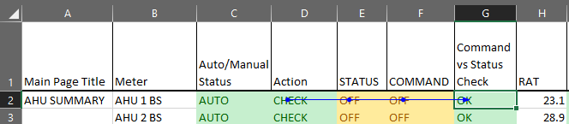

**Precedent Dependent Relation**

**Formula:** **=IF(EXACT(D2,"CHECK"),IF(EXACT(E2,F2),"OK","FAULT"),"XX")**

* **RAT Value Status:** Based upon the current Return air temperature and the AHU run status we compute the appropriate range of temperature for the RAT and compare it with the present RAT value and predict the status

If the AHU is ON, the RAT must be below the threshold limit of 26

If the AHU is ON, the RAT must be in the range of 22-30 degrees.

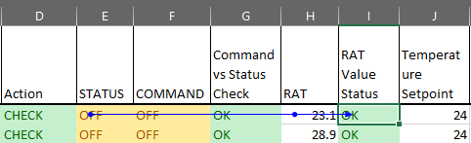

**Precedent Dependent Relation**

**Formula:** **=IF(EXACT(E2,"ON"),IF(H2<27,"OK","FAULT"),IF(AND(H2>21,H2<31),"OK","FAULT"))**

* **Delta:** It is just the temperature difference between the Return Air temperature and the temperature Setpoint

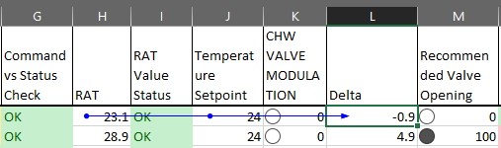

**Precedent Dependent Relation**

**Formula: =(H2-J2)**

* **Recommended Valve Opening:** The valve opening is decided based upon the delta value of the AHU based on the following Condition:
* If Delta>1 then the valve opening must be 100%
* For Delta =1 the Valve must be open at 80% and for delta=0 the valve must be open at 50% and for all the values in between the delta must be proportional to this 80-50 limits
* Similarly for Delta=-1 the valve must be open at 30% and for the values that fall in between 0 and -1 must lie between 50% and 30%
* For Delta lesser than -1 the valve opening must be set at 0%

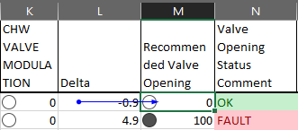

**Precedent Dependent Relation**

**Formula: =IF(L2>1,100,IF(AND(L2>0,L2=0),30*L2+50,IF(AND(L2>-1,L2=-1),20*L2+50,0)))**

* **Valve Opening Status Comment:** The valve opening status comment field compares the Recommended and the actual valve opening and tells the user that the valve I at a proper modulation or not.

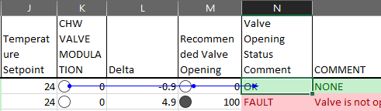

**Precedent Dependent Relation**

**Formula: =IF(M2=K2,"OK","FAULT")**

* **Comment:** Based upon the Valve status comment and the actual variation between the recommended and the actual values we generate the comment for the user.

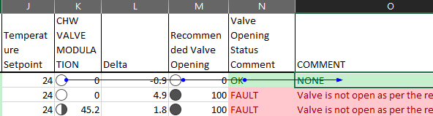

**Precedent Dependent Relation**

**Formula: =IF(EXACT(N2,"FAULT"),IF(M2<K2,"Valve is open more than requirement”, “Valve is not open as per the requirement"),"NONE")**

**Process Flow for AHU:**

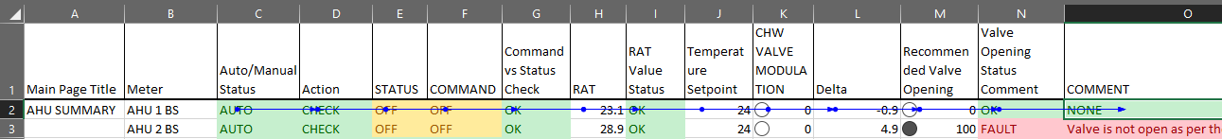

The Process Flow of a complete Process for a meter on how it is evaluated.

**The Chiller Snaglist**

**Sheet Parameters:**

(The values in Yellow are provided by the user from the site during REMOTE HEALTH CHECK

The values in cyan are computed automatically based upon the entry of the Yellow marked parameters)

* **Main Page Title:** The Main page title depicts the page which is being referred with regard to the set which is being evaluated on the site
* **Meter:** This Depicts the meter or the datapoint which is being referred to with respect to the analysis.
* **Chiller Status:** The chiller status is the run status of the chiller i.e. whether it is ON or OFF.
* **Condenser Valve Status:** The condenser valve status depicts whether the condenser water inlet valve is open or not.
* **Evaporator Valve Status:** The Evaporator valve status depicts whether the evaporator water inlet valve is open or not.
* **Condenser Valve Comment:** Based upon the Chiller run status and the Condenser Valve status we compute the Valve Comments and indicate the Faults.
* **Evaporator Valve Comment:** Based upon the Chiller Run status and the Evaporator Valve Status we compute the Val Comments and indicate the Faults.
* **Evaporator Inlet Temperature:** Evaporator Inlet Temperature is the value of the inlet temperature of the water which is provided as an input to the chiller.
* **Evaporator Outlet Temperature:** Evaporator Outlet Temperature is the outlet temperature of the chilled water which is provided as an output by the chiller after processing it using refrigerants and other techniques.
* **Delta:** Delta is the temperature difference of the inlet and the outlet temperature values of the water which is passed through the chiller.
* **Evaporator Inlet Status:** This field Checks whether the Inlet Temperature of the water entering the chiller is in the normal range or not for the chiller to process appropriately.
* **Evaporator Outlet Status:** The Evaporator Outlet status field checks whether the outlet temperature of the water from the chiller is in the desired range or not for the cooling purpose.
* **Evaporator Delta Status:** The Evaporator delta status field check whether the chiller is performing at its capability or not i.e. whether it is able to provide the necessary temperature difference or not for the water supplied across it.

**Conditions to detect the Faults:**

* **Condenser Valve Comment:** The Condenser valve comment is an important parameter to be check as if the chiller run status is on then the water must be provided as an inlet to the condenser as without the supply of water we are wasting power by running the chiller Unnecessarily and vice versa.

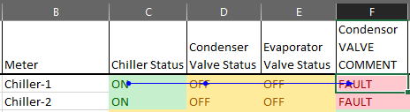

**Precedent Dependent Relation**

**Formula:** **=IF(EXACT(C2,D2),"OK","FAULT")**

* **Evaporator Valve Comment:** Similar to the condenser valve we have to check the evaporator valve in order to match the status of the chiller with the evaporator water inlet valve to prevent either wastage of water or power when either of the parameter is inactive.

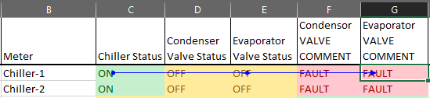

**Precedent Dependent Relation**

**Formula: =IF(EXACT(C2,E2),"OK","FAULT")**

* **Delta:** Delta is simply the temperature difference of the evaporator inlet and outlet.

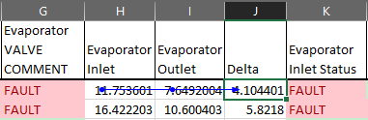

**Precedent Dependent Relation**

**Formula: =(H2-I2)**

* **Evaporator Inlet Status:** The evaporator inlet status field checks whether the inlet temperature for the evaporator is in the desired range or not.

The inlet temperature must be in the range of 12-14 degrees

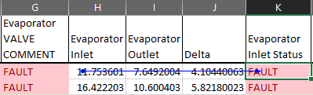

**Precedent Dependent Relation**

**Formula: =IF(AND(OR(H2>12,H2=12),OR(H2<14,H2=14)),"OK","FAULT")**

* **Evaporator Outlet Status:** The evaporator outlet status field checks whether the outlet temperature for the evaporator is in the desired range or not.

The outlet temperature must be in the range of 6-10 degrees

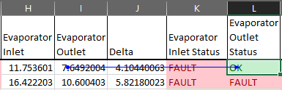

**Precedent Dependent Relation**

**Formula: =IF(AND(OR(I2>6,I2=6),OR(I2<10,I2=10)),"OK","FAULT")**

* **Evaporator Delta Status:** The evaporator delta status check whether the chiller is providing the appropriate drop in temperature or not for the water supplied across it.

Condition: Delta must be between 4-5 degrees.

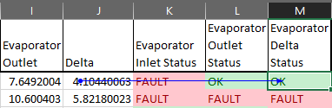

**Precedent Dependent Relation**

**Formula: =IF(AND(OR(J2>4,J2=4),OR(J2<5,J2=5)),"OK","FAULT")**

**Process Flow:**

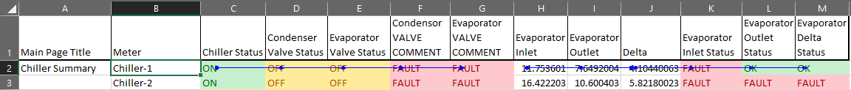

**Linking Values to the Snaglist Automatically:**

In order to generate the Snaglist Automatically we have to provide data source to the fields in the snaglist for this there are 2 separate process (1 for Desigo Insight and 1 for Desigo CC)

* **Desigo Insight:**

For Desigo Insight Based Systems We need to follow the following Procedure:

1. Make use of the DI2EMC tool in order to generate .csv files for the data which will have all the components and the values corresponding to a timestamp.
2. While configuring the Trend in DI2EMC we set the period such that we get the last 2-3 values of each and every component.
3. Once we get the data in csv files we first need to open every file in any text editor like( notepad or atom)
4. Once the File is open in the text editor we need to add a line at the beginning as (sep=;)

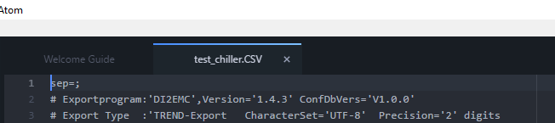

1. Once this is done we can now open the file in excel and get the file in a structured format.
2. Upon opening the file, we will get something like this

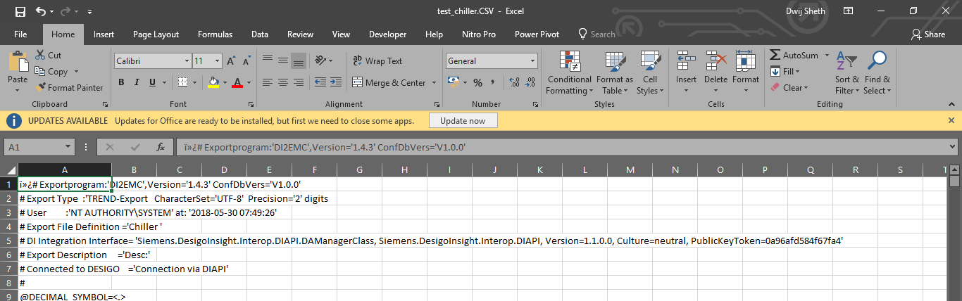

1. Now we need to apply filters so for this we will select the cell A1 and press Ctrl+Shift+L

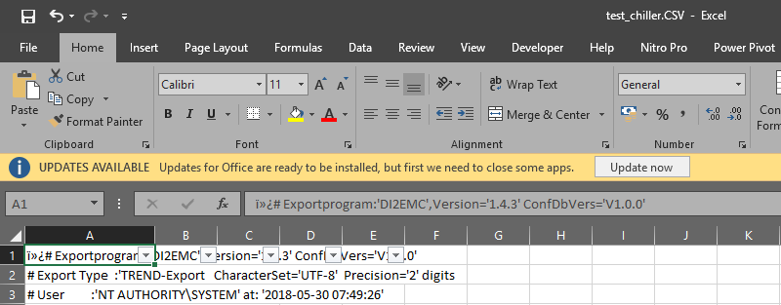

1. Now we have to apply a custom Date Filter to this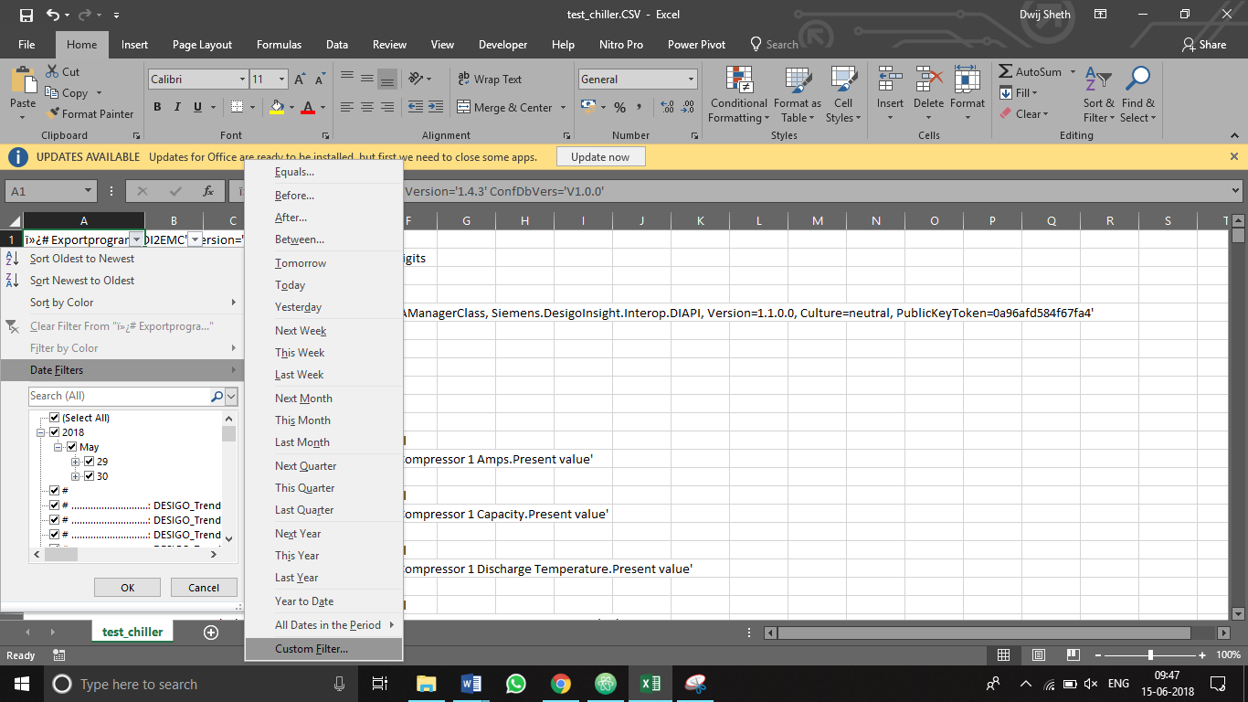

1. Before entering the Custom filter We will roughly inspect the file and find the latest value that has been logged for the components.

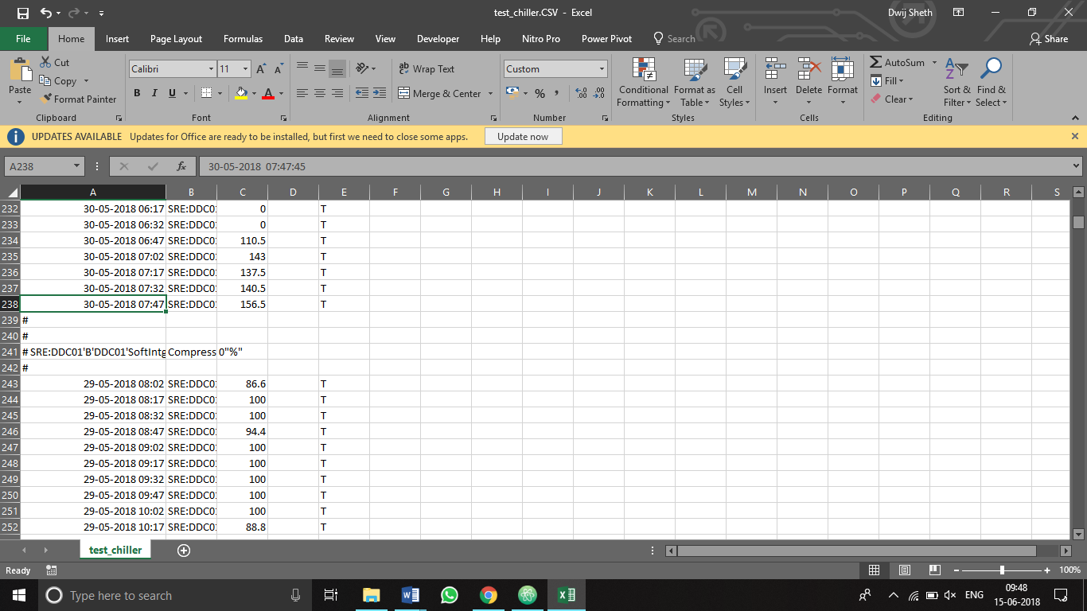

Like in the above image we can see that the highlighted value is the latest value that is fed into the log so we can use this value will applying the custom filter shown above.

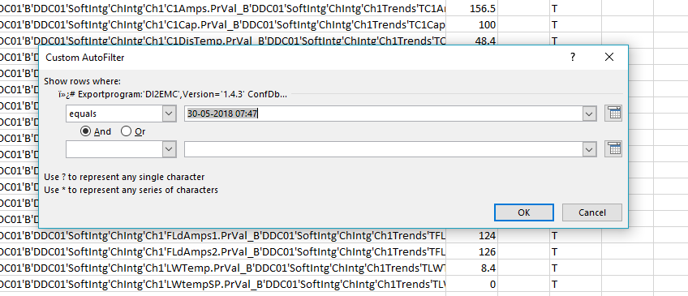

1. Now we will copy all the values from here to a new excel Sheet (Or replace an Existing configured Excel File).
2. Up to point 10, this was the procedure that needs to be done for every REMOTE HEALTH CHECK.

**Configuring the Excel File for the Automatic REMOTE HEALTH CHECK (One Time Configuration to be done for Every Site):**

1. Once all the data is copied into the New Excel File we need to map the data to the auto snaglist.
2. For this we need to place the auto snag template and the Excel Data file in to the same directory.
3. Now open the Auto Snaglist
4. For mapping the Data at the Respective Place Just USE = in the necessary cell and click on the Data point on the excel containing all the Data points.
5. Repeat the Above Steps for all the Datapoints.

Now for every new REMOTE HEALTH CHECK for the Existing site we just need to follow the 10 points given above and get the data in to the excel file and replace the existing values with the new ones by pasting it on the Existing One and the launch the Auto snag sheet so that the new values are copied into it and the Snaglist is generated automatically.

* **Desigo CC**

One time Setup:

1. For Desigo CC Based systems we need to configure reports for the complete system.
2. For this go to Reports in Desigo CC
3. Create a new Report
4. Put all the needed parameters one by one.
5. For Each value that is added we need to add a row filter with value 3 (or a small number as this the number of recent values that we want)
6. Apart from this we need to add a time filter such that last 20-30-minute data can be obtained which can be configured in the time filter option.
7. Repeat the filter application for all the data points.
8. Once done we can export the list to excel and download it on our computer.
9. Also, to further automate this process we can use the reaction processor to automatically update the excel file and download it onto the BMS system as per a schedule what is given to the reaction processor.
10. Finally, the Excel file is what we need to map the data to the auto snag template for which the procedure is explained below.
11. The report that we will get for Desigo CC based systems will have separate datapoints in separate sheets and every sheet will have the last 3 values of every component or as per the row filter value that was set earlier.
12. Now we will have to follow the same procedure as per the Desigo insight systems that was done earlier for data mapping
13. We need to open the autosnag excel file and use the = operator where the data has to be retrieved and click the corresponding cell from the report file which will be placed in the same directory as the autosnag template.
14. Similarly, we will just repeat the mapping until all the parameters have been mapped.

**For Every Further REMOTE HEALTH CHECK we need to follow the following steps:**

1. We have to create the excel file of the report by taking the clients PC remotely.
2. Once the Report has been generated we have to copy the excel to our computer
3. Once the file is here we have to replace the existing excel file in the directory with the new one such that the name of the file is the same or simple force save it on the existing file.
4. Once the save/replace action is done we just need to open the auto snag file as well as the data file side by side and the snaglist will be updated to the latest state.